

PROJECT NAME: LIBRARY MANAGEMENT SYSTEM
PERFORMED BY: SAIKOT ROY, DINESH SIKDER
TECHNOLOGY USED: PL/SQL USING ORACLE DBA
COLLEGE: GOVT. COLLEGE OF ENGINEERING & CERAMIC TECHNOLOGY

44, BD Block, Sector 1, Salt Lake City, Kolkata, West Bengal 700064



ACKNOWLEDGEMENT:

I take this opportunity to express my profound gratitude and deep regards to my faculty Mohan Chichia for his exemplary guidance, monitoring and constant encouragement throughout the course of this project. The blessing, help and guidance given by him/her time to time shall carry me a long way in the journey of life on which I am about to embark.
I am obliged to my project team members for the valuable information provided by them in their respective fields. I am grateful for their cooperation during the period of my assignment.

Saikot Roy
Dinesh Sikder

INDEX:

Introduction------------------------------------------------------------------------- 01
System Analysis--------------------------------------------------------------------- 02
Feasibility Analysis----------------------------------------------------------------- 03
Hardware Configuration-----------------------------------------------------------03
Software Configuration----------------------------------------------------------- 04
Dataflow Diagram------------------------------------------------------------------ 04
Screenshots-------------------------------------------------------------------------- 06
System Design------------------------------------------------------------------------08
Database Design---------------------------------------------------------------------09
System Implementation------------------------------------------------------------10
Code------------------------------------------------------------------------------------10
Certificate------------------------------------------------------------------------------14

INTRODUCTION:

The project titled Library Management System is Library management software for monitoring and controlling the transactions in a library .The project “Library Management system” is developed in sql,pl/sql which mainly focuses on basic operations in a library like adding new member, new books, and updating new information, searching books and members and facility to borrow and return books.
“Library Management System” is a windows application written for 32/64 bit Windows operating systems, designed to help users maintain and organize library. Our software is easy to use for both beginners and advanced users. It features a familiar and well thought-out, an attractive user interface, combined with strong searching Insertion and reporting capabilities. The report generation facility of library system helps to get a good idea of which are the books borrowed by the members, makes users possible to generate reports’ hard copy. The software Library Management System has four main modules.

- Insertion to Database Module – User friendly input screen

- Extracting from Database module – Attractive Output Screen

- Report Generation module – borrowed book list & Available book list

- Search Facility system – search for books and members

1
SYSTEM ANALYSIS:

EXISTING SYSTEM:

System Analysis is a detailed study of the various operations performed by a system and their relationships within and outside of the system. Here the key question is- what all problems exist in the present system? What must be done to solve the problem? Analysis begins when a user or manager begins a study of the program using existing system.
Then the proposed system should be analysed thoroughly in accordance with the needs.

System analysis can be categorized into four parts.

      - System planning and initial investigation

      - Information Gathering

      - Applying analysis tools for structured analysis

      - Feasibility study

      - Cost/ Benefit analysis

PROPOSED SYSTEM:

Proposed system is an automated Library Management System. Through our software user can add members, add books, search members, search books, update information, edit information, borrow and return books in quick time. Our proposed system has the following advantages.

➢User friendly interface

➢Fast access to database

➢Less error

➢Search facility

➢Look and Feel Environment

All the manual difficulties in managing the Library have been rectified by implementing computerization.

2
FEASIBILITY ANALYSIS:

Feasibility is the study of impact, which happens in the organization by the development of a system. The impact can be either positive or negative. When the positives nominate the negatives, then the system is considered feasible. Here the feasibility study can be performed in two ways such as technical feasibility and Economical Feasibility.

Technical Feasibility:

We can strongly says that it is technically feasible, since there will not be much difficulty in getting required resources for the development and maintaining the system as well. All the resources needed for the development of the software as well as the maintenance of the same is available in the organization here we are utilizing the resources which are available already.

Economical Feasibility:

Development of this application is highly economically feasible .The organization needed not spend much m one for the development of the system already available. The only thing is to be done is making an environment for the development with an effective supervision. I f we are doing so , we can attain the maximum usability of the corresponding resources .Even after the development , the organization will not be in a condition to invest more in the organization .Therefore , the system is economically feasible.

HARDWARE CONFIGURATION:
Processor: | Pentium III or Above
RAM : | 128 MB or Above
Hard Disk: | 20GB or Above
Monitor: | 15” Color monitor
Key Board: | 122 Keys or Any

3
SOFTWARE CONFIGURATION:

Operating System : | Windows NT, 98, XP,VISTA,8,10
Language: | PL/SQL,ORACLE DATABASE
Database: | Oracle

DATAFLOW DIAGRAM:
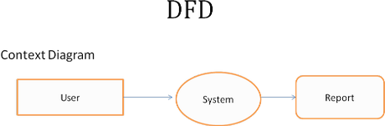
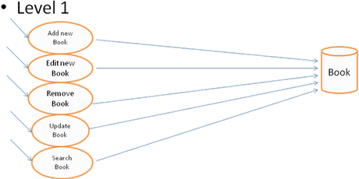

4

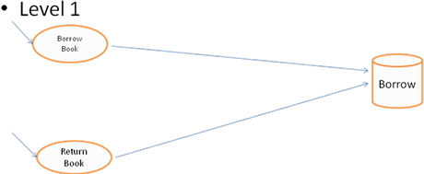

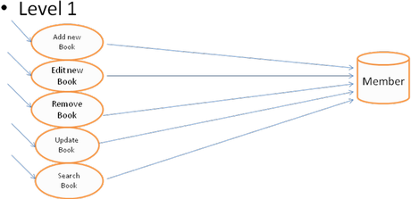

5
SCREENSHOTS:
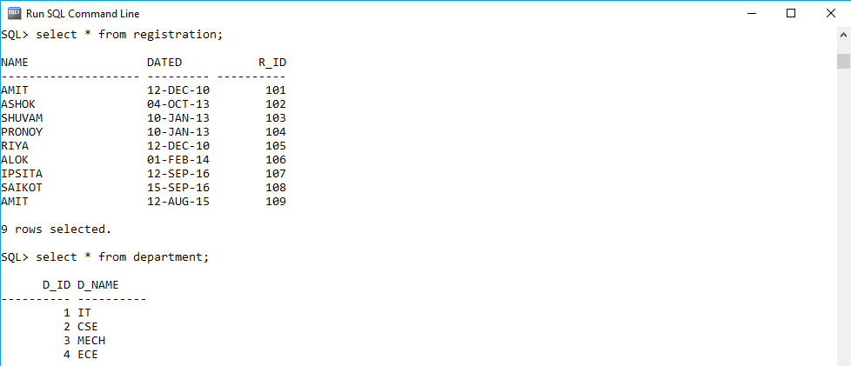

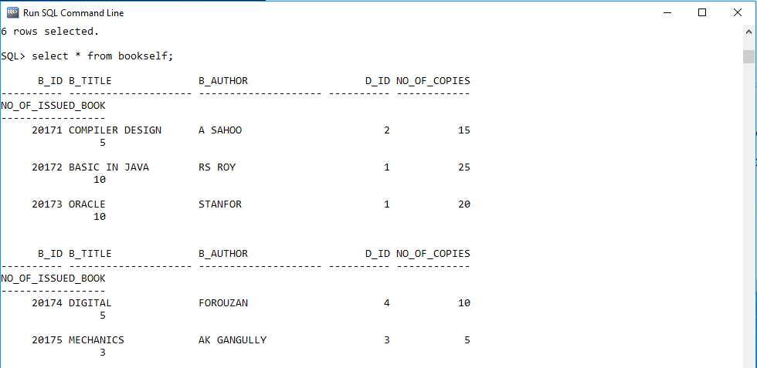

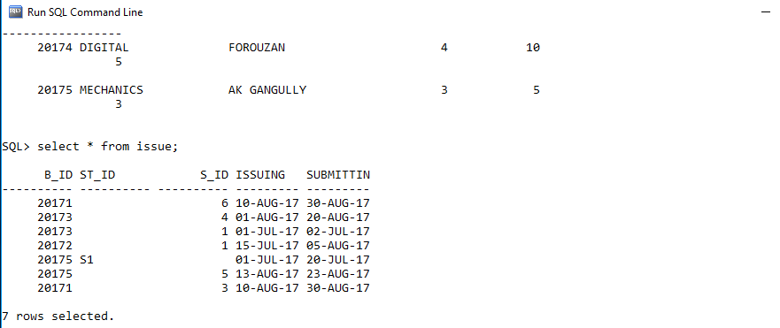



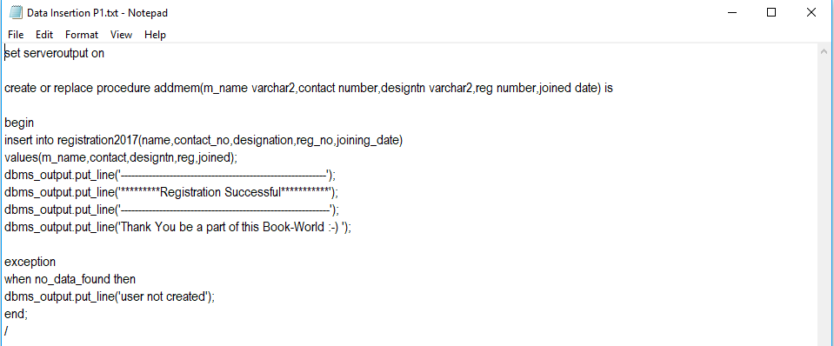

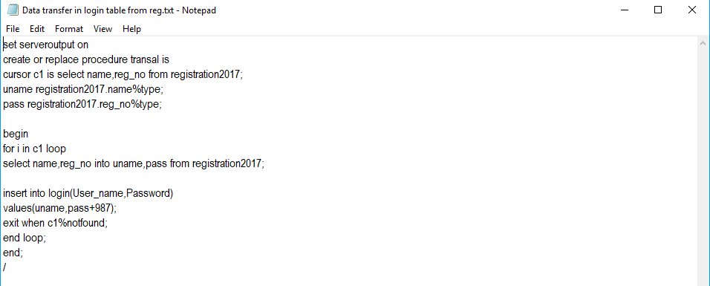

SYSTEM DESIGN:

INPUT DESIGN

Input design is the process of converting user-oriented input to a computer based format. Input design is a part of overall system design, which requires very careful attention .Often the collection of input data is the most expensive part of the system. The main objectives of the input design are …

1. Produce cost effective method of input
2. Achieve highest possible level of accuracy
3. Ensure that the input is acceptable to and understood by the staff.

The goal of designing input data is to make enter easy, logical and free from errors
as possible. The entering data entry operators need to know the allocated space for each field; field sequence and which must match with that in the source document. The format in which the data fields are entered should be given in the input form .Here data entry is online; it makes use of processor that accepts commands and data from the operator through a key board. The input required is analyzed by the processor. It is then accepted or rejected. Input stages include the following processes

Data Recording

Data Conversion

Data Verification

Data Control

Data Transmission

Data Correction

One of the aims of the system analyst must be to select data capture method and devices, which reduce the number of stages so as to reduce both the changes of errors and the cost .Input types, can be characterized as.

- External
- Internal

- Operational

- Interactive

Input files can exist in document form before being input to the computer. Input design is rather complex since it involves procedures for capturing data as well as inputting it to the computer. 8

OUTPUT DESIGN

Outputs from computer systems are required primarily to communicate the results of processing to users. They are also used to provide a permanent copy of these result for latter consultation. The right output must be available for the people who find the system easy to use. The outputs have been defined during the logical design stage. If not, they should defined at the beginning of the output designing terms of types of output connect, format, response etc, Various types of outputs are

• External outputs

• Internal outputs

• Operational outputs

• Interactive outputs

All screens are informative and interactive in such a way that the user can full fill his requirements through asking queries.

DATABASE DESIGN:

The general theme behind a database is to handle information as an integrated whole. A database is a collection of interrelated data stored with minimum redundancy to serve many users quickly and effectively. After designing input and output, the analyst must concentrate on database design or how data should be organized around user requirements. The general objective is to make information access, easy quick, inexpensive and flexible for other users. During database design the following objectives are concerned:-

Controlled Redundancy Data independence

Accurate and integrating More information at low cost

Performance Privacy and security
9
SYSTEM IMPLEMENTATION:

Implementation is the stage in the project where the theoretical design is turned into a working system. The implementation phase constructs, installs and operates the new system. The most crucial stage in achieving a new successful system is that it will work efficiently and effectively.
There are several activities involved while implementing a new project they are

• End user training

• End user Education

• Training on the application software

• System Design

• Parallel Run To New System

• Post implementation Review

CODE:

LMS Table:
- REGISTRATION
- STUDENT
- DEPARTMENT
- STAFF
- BOOKSELF
- ISSUE

LMS Table scripts:
CREATE TABLE REGISTRATION( NAME VARCHAR2(20),DATED DATE,R_ID INT PRIMARY KEY);
CREATE TABLE DEPARTMENT( D_ID NUMBER(10) PRIMARY KEY,D_NAME VARCHAR2(10));
CREATE TABLE STUDENT( S_ID NUMBER(20) PRIMARY KEY,S_NAME VARCHAR2(20),D_ID REFERENCES DEPARTMENT,CONTACT_NO INTEGER,YEAR INTEGER,R_ID REFERENCES REGISTRATION);
CREATE TABLE STAFF(ST_ID VARCHAR2(10) PRIMARY KEY,ST_NAME VARCHAR2(10),DESIGNATION VARCHAR2(20),R_ID REFERENCES REGISTRATION);
CREATE TABLE BOOKSELF( B_ID NUMBER(5) PRIMARY KEY,B_TITLE VARCHAR2(20),B_AUTHOR VARCHAR2(20),D_ID REFERENCES DEPARTMENT,NO_OF_COPIES NUMBER(20),NO_OF_ISSUED_BOOK NUMBER(20)); 10
CREATE TABLE ISSUE( B_ID REFERENCES BOOKSELF,ST_ID REFERENCES STAFF, S_ID REFERENCES STUDENT,ISSUING DATE,SUBMITTING DATE);
---ADD A NEW BOOK---

Create or replace procedure addbook is

bknam char(15);
auth char(15);
tot number(5);
id number(5);
no number(5);
i number(3);
begin
bknam:='&bknam';
auth:='&auth';
tot:=&tot;
insert into book_rec values(bknam,auth,tot,tot);
for i in 1..tot loop
select MAX(book_id) into no from book_details;
if no is not null then
id:=no+1; else
id:=1; end if;
insert into book_details values(id,bknam,null);
end loop;end;
/
---CREATE A NEW MEMBER---

Create or replace procedure memrship is
nam char(15);
id number(5);
no number(5);
i number(3); begin
nam:='&nam';
select MAX(mem_id) into no from membership_rec;
if no is not null then
id:=no+1; else
id:=1; end if;
insert into membership_rec values(id,nam,null);
dbms_output.put_line('Mr/Mrs/Miss. '||nam||', your membership id is '||id);
end;
/
---ISSUE A BOOK---

Create or replace procedure issuebook is
bknam char(15);
mid number(5);
bid number(5);
dat date;
nam char(15);
n number(5); begin
bknam:='&bknam';
select MIN(book_id) into bid from book_details where book_name=bknam and mem_id is null;
mid:=&mid;
select mem_name into nam from membership_rec where mem_id=mid;
update book_details set mem_id=mid where book_id=bid;
select no_of_books_taken into n from membership_rec where mem_id=mid;
if n is null then n:=0; end if;
update membership_rec set no_of_books_taken=n+1 where mem_id=mid;
update book_rec set available_copies=available_copies-1 where book_name=bknam;
select ADD_months(sysdate,1) into dat from dual;
insert into circulation_rec values(bid,mid,sysdate,dat);
end;
/

~~~~~~~~~~~~~~~~ CERTIFICATE~~~~~~~~~~~~~~~~

This is to certify that Mr SAIKOT ROY of GOVERNMENT COLLEGE OF ENGINEERING & CERAMIC TECHNOLOGY registration number: 141130110065, has successfully completed a project on LIBRARY MANAGEMENT SYSTEM using ORACLE DBA under the guidance
Of Mr Mohan Chichila.

---------------------------
Signature



~~~~~~~~~~~~~~~~ CERTIFICATE~~~~~~~~~~~~~~~~

This is to certify that Mr DINESH SIKDER of GOVERNMENT COLLEGE OF ENGINEERING & CERAMIC TECHNOLOGY registration number: 141130110049, has successfully completed a project on LIBRARY MANAGEMENT SYSTEM using ORACLE DBA under the guidance Of Mr Mohan Chichila.

---------------------------
Signature


